**RFID door lock using arduino**

**Introduction**

RFID based security system using the Arduino project has **an RFID reader attached to it**. RFID reader reads the unique alphanumeric code of RFID tags and sends it to Arduino. Then Arduino detects whether an RFID card is valid or invalid. If the card is invalid then the system turns on the buzzer.

**RFID**stands for **Radio Frequency Identification**. Each RFID card has a unique ID embedded in it and a RFID reader is used to read the RFID card no. **EM-18 RFID reader** operates at 125 KHz and it comes with an on-chip antenna and it can be powered with 5V power supply. It provides serial output along with weigand output. The range is around 8-12cm.

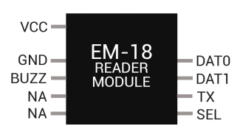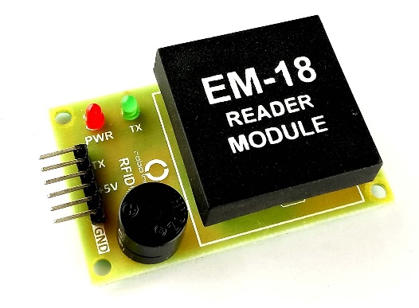

**Components**

* Arduino UNO
* RFID EM-18 Reader Module with Tags
* Relay 5v
* LED
* Buzzer
* Connecting wire
* Resistors

**Application**

* Security control and jewelry.
* Cosmetics and medicines.
* Control of disposals and tools in hospitals.
* Libraries.
* Voting machines
* Aviation baggage control

**Objective**

During this activity ,you will help students to achieve following objectives

1. Understanding the principle and operation of RFID EM-18 sensor module
2. Design algorithm and flowchart for RFID sensor module
3. Programming RFID EM-18 Sensor module using Arduino uno
4. Interfacing RFID EM-18 module withArduino uno

**Programming steps**

1. initialize RFID tag by char tag and define char input[12] as array size

2. initialse counter at 0 ans set Boolean flag as 0

3. define ports for LED and buzzer

4. **check if there is any serial data available means** RFID tag is getting scanned

**5. compare the scanned RFID card no**. with the number which we have defined in char tag[] array. If both the umber matches then we set the flag variable to 1 and if the wrong card is scanned or both the numbers don’t match then we set the flag variable to 0.

**6.If you place right RFID tag**, the flag gets equal to 1,relay gets high and door lock will opened

**7.If you place the wrong RFID card**, the flag will be zero and the buzzer start beeping alerting that the RFID card is wrong.

**Program**

char tag[] ="180088F889E1";   
char input[12];           
int count = 0;          
boolean flag = 0;   
void setup()    
{  
  pinMode(2,OUTPUT);   
  pinMode(3, OUTPUT);  
  pinMode(4, OUTPUT);  
  Serial.begin(9600);

}  
    void loop()  
{  
  digitalWrite(3,1);  
  if(Serial.available())  
  {  
    count = 0;  
  while(Serial.available() && count < 12)  
    {  
      input[count] = Serial.read();   
      count++;   
      delay(5);  
    }  
    if(count == 12)  
    {  
      count =0;  
      flag = 1;  
      while(count<12 && flag !=0)    
      {  
        if(tag[count]==input[count])  
        flag = 1;   
        else  
        flag= 0;  
}  
    if(flag == 1)   
    {  
      digitalWrite(2,HIGH);  
       digitalWrite(3,LOW);  
      delay(5000);  
      digitalWrite(2,LOW);  
    }  
     if(flag == 0)  
      {  
       for(int k =0; k<= 10; k++)  
      {  
        digitalWrite(4,HIGH);  
      }  
      }  
    }  
  }  
}

**Hardware**

**Instructions**

**1.connect VCC and GND pin of EM-18 RFID module to supply and ground pin of Arduino**

**2.connect transmitter pin(TX) pin of module to receiver pin (RX) pinof Arduino**

**3.connect relay VCC and GND pin to Arduino supply voltage and ground pin respectively**

**4.connect signal out pin of relay to positive end of LED 1 whereas negative end is grounded.LED2 positive end is connected to digital pin 3**

**5. connect buzzer such that positive terminal is connected to the digital**

**pin 4 and negative terminal to the ground.**

